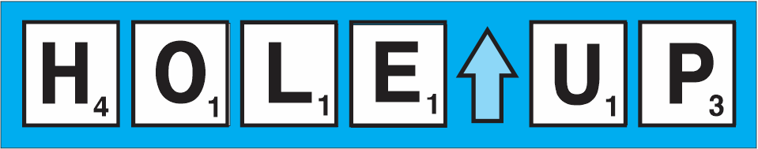
A Holey Word Game
(October 2, 2023)
Hole UP is a word building game for one or more players, generally aged 7+. Players take turns stacking up cards with holes to make three-letter words.

COMPONENTS
- 88 double sided letter cards
- 4 bases
- Six dry erase score boards
- Dry erase marker

MODES
There are three ways of playing HOLE UP
- Single Stack
- Square
- Crosswords

All modes can be played solo (solitaire), with or without scoring.

STACK MODE SETUP
- Shuffle the letter cards and place as the draw pile.
- Draw and place one card as the base of the “stack”.

SINGLE STACK GAME PLAY
The goal in stack mode is to end the game with no cards in-hand.
Here are your actions:
- Draw the next card or play an unplayable card.
- Determine if either side of your card can be stacked to form a word.
- Stack the card, if possible, to make a new word.
- Combine two unplayable cards (when available) to make a word and stack both cards.
- Keep unplayable card(s) in-hand until later.

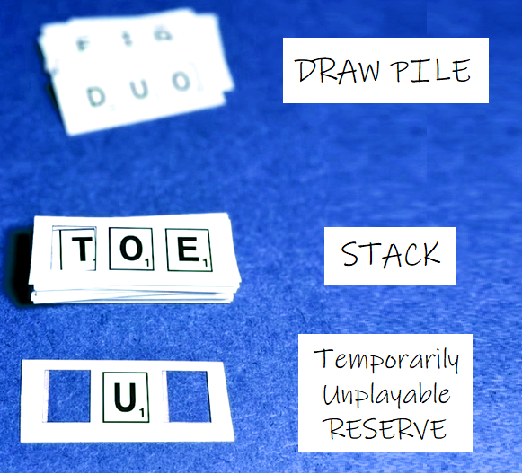

SQUARE AND CROSSWORDS SETUP
- Shuffle the letter cards.
- Place the cards within easy reach of all players.
- Draw the top card and place as the starter card or one of the sides in the square “stack”.
- Give each player one card.
- Give each player a score card.

SQUARE GAME PLAY
On their turn, a player can perform the following actions:
- Determine if either side of their card can be stacked to form a word.
- Stack or join one of their cards to make a word
- Draw a new card if they cannot make a word.

Example of a square.  The words in play are:  DID DAY HAY HID | 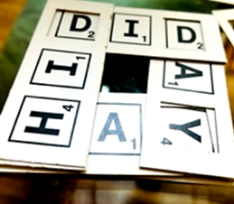

WORD ALIGNMENT
Words are aligned based on the orientation of the middle letter. The middle letter indicates the direction to read the new word formed.
All words are valid:  NOD NIP PAN DEN  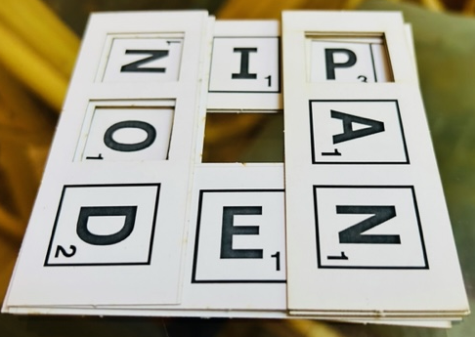 | “GAP” is NOT a valid word:  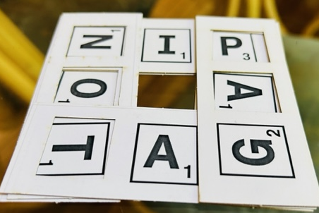

CROSSWORDS GAME PLAY
On their turn, a player can perform the following actions:
Determine if either side of their card can be stacked to form a word.
Draw a new card if they cannot make a word.
Stack one of their cards on one of the cards in play.
The direction of all words is based on the orientation of the middle letter. Especially note the direction of “ZOO”. | 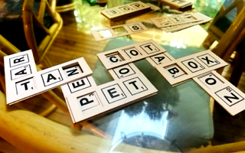

FORMING A WORD
A three-letter word is formed using a combination of the letters beneath and on the card played.
For example, with the stack showing H A T

and the card to be played has 0 I P , the new word would be H I P, scoring 8 points.

SCORING
Add up the point values of the letters in each word made. Note that you can score more than one word in square and crossword modes. Add the value to the score card.

ENDING A GAME
The game is over once the draw pile has been exhausted and no more words can be formed by the player(s). If scoring, deduct the points of the letters in-hand.

STRATEGIES
- Examine both sides of a card to optimize a score.
- Hold on to a valuable card to use later, for example one with high point value letter like X or Z.
- In crosswords mode, longer words are possible: 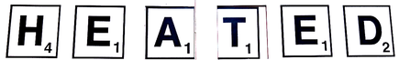

USING THE BASES
Optionally for Stack and Square modes, grab a random base to help with tile placement and starter alignment.

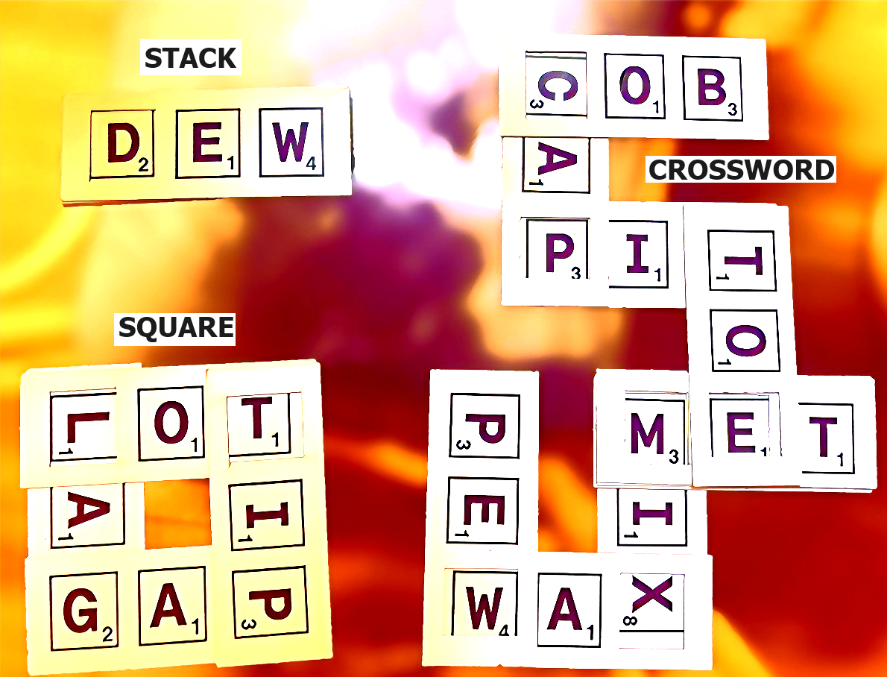

Copyright © 2023 Knowledge Probe Inc (dba Brainy Games)
www.BRAINY.games

